Yamaha Pacifica 604

[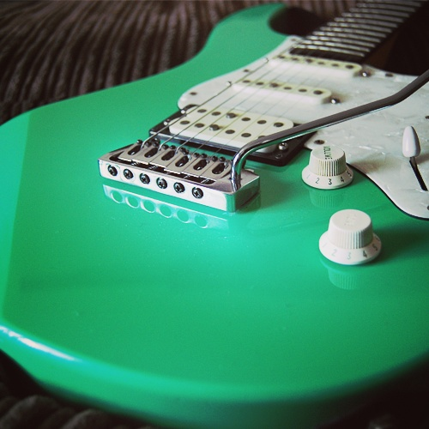](http://www.axebition.com/sites/default/files/guitars/yamaha-pacifica-604-02.png?slideshow=true&slideshowAuto=false&slideshowSpeed=4000&speed=350&transition=elastic)

[«](http://www.axebition.com/electric-guitar/yamaha-pacifica-604)

Top of Form

**Made in:** Taiwan, Province of China **Construction:** Bolt-On

**Orientation:**Right handed **Years:**1994 to 1995

**Body Material:**Alder

**Body colour:**Black, Cherry Sunburst, Sea foam Green, Antique Sunburst

**Body finish:**Gloss **Pickguard colour:** Pearloid White

**Pickup Brand: All** Yamaha **Pickup Configuration:**HSS really SSSS

**Tone knob: 1 Volume knob:** 1 **5 way switch:**

**Coil split:**Yes **Control color:** White

**Description:**

The **Yamaha Pacifica 604** is an offset double-cut strat like guitar that preceded the[Yamaha Pacifica 604W](http://www.axebition.com/node/91) but instead of the[Wilkinson VS100 bridge](http://www.axebition.com/node/84), has a Yamaha Vintage Custom vibrato system machined from solid brass.  It looks like this guitar has two single coil pickups with a humbucker in the bridge position. The bridge position actually contains two coupled single coil pickups making it a total of 4 Alnico V single coils in this guitar. Hence the 4 in the model name "Pacifica 60**4**". The tone knob doubles as a (push-push) coil tap.

**Nut Width:**41 mm (1-5/8 inch)**Thickness at nut:** 20.90mm

**Thickness at 12th fret:**22.90mm

**Neck Material:** Maple **Neck colour:** Natural **Neck finish:** Satin

No binding

**Fretboard:**Rosewood **Fretboard radius:** 350 mm (13.75 inch)

**Scale Length:**25.5 inch (648 mm) **Frets:** 22

**Fret Size:**Medium **Inlays** Dot **Inlay colour:** pearl ,Locking Tuners

**Headstock colour:** Natural **Headstock finish:** Satin

**Headstock angle:**straight **Tuning Machines:** Sperzel

**Tuning Ratio:**12:1 Ratio **Bridge brand:** Yamaha

**Bridge type:**Standard type **Hardware colour:** Chrome Satin