Yamaha Pacifica 604
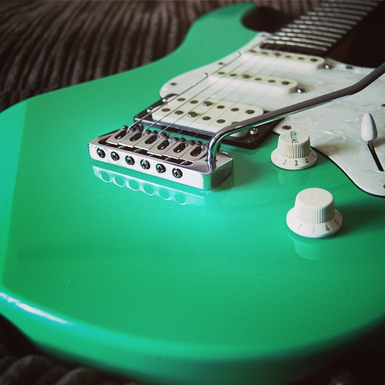
«

Made in: Taiwan, Province of China Construction: Bolt-On
Orientation: Right handed Years:1994 to 1995
Body Material:Alder
Body colour: Black, Cherry Sunburst, Sea foam Green, Antique Sunburst
Body finish: Gloss Pickguard colour: Pearloid White
Pickup Brand: All Yamaha Pickup Configuration: HSS really SSSS
Tone knob: 1 Volume knob: 1 5 way switch:
Coil split: Yes Control color: White
Description:
The Yamaha Pacifica 604 is an offset double-cut strat like guitar that preceded theYamaha Pacifica 604W but instead of theWilkinson VS100 bridge, has a Yamaha Vintage Custom vibrato system machined from solid brass. It looks like this guitar has two single coil pickups with a humbucker in the bridge position. The bridge position actually contains two coupled single coil pickups making it a total of 4 Alnico V single coils in this guitar. Hence the 4 in the model name "Pacifica 604". The tone knob doubles as a (push-push) coil tap.

Nut Width: 41 mm (1-5/8 inch)Thickness at nut: 20.90mm
Thickness at 12th fret: 22.90mm
Neck Material: Maple Neck colour: Natural Neck finish: Satin
No binding
Fretboard: Rosewood Fretboard radius: 350 mm (13.75 inch)
Scale Length: 25.5 inch (648 mm) Frets: 22
Fret Size: Medium Inlays Dot Inlay colour: pearl ,Locking Tuners
Headstock colour: Natural Headstock finish: Satin
Headstock angle: straight Tuning Machines: Sperzel
Tuning Ratio: 12:1 Ratio Bridge brand: Yamaha
Bridge type: Standard type Hardware colour: Chrome Satin

