## Highway 1 and American Special Info

### Pricing

To give an idea of the relative prices only the Fender RRPs are:

Am Standard H1 Am Special

2011 $1300 $999 $1100

2014 $1730 disc. $1289

Highway 1

V1 2002 to 2006

SSS

|  |  |
| --- | --- |
| Headstock | Small 2 string trees |
| Pickguard | White 11 Screw Laminated Plastic white controls |
| Bridge | 6 point/vibrato unit |
| Finish | Satin |
| Neck | Fretted Maple or Maple with Rosewood |
| Body | Satin Finish Sapphire Blue, Crimson Red, Honey Blonde or 3 colour sunburst* |
| PUPs | 3 White 6 polepiece |
| Other features | No micro tilt blank neckplate |

*Don’t know if other colours were available earlier but in 2006 Sapphire Blue, Crimson Red, Honey Blonde and 3 colour Sunburst on the SSS were the only available colours. The colours below similarly for the HSS

HSS version available from 2003

|  |  |
| --- | --- |
| Headstock | Large 2 string trees |
| Pickguard | White 11 Screw Laminated Plastic |
| Bridge | 6 point/vibrato unit |
| Finish | Satin |
| Neck | Maple with Rosewood |
| Body | Satin Finish Sapphire Amber Ebony and Walnut* |
| PUPs | 2 White 6 polepiece 1 Black coverless Humbucker |
| Other features | No micro tilt blank neckplate |

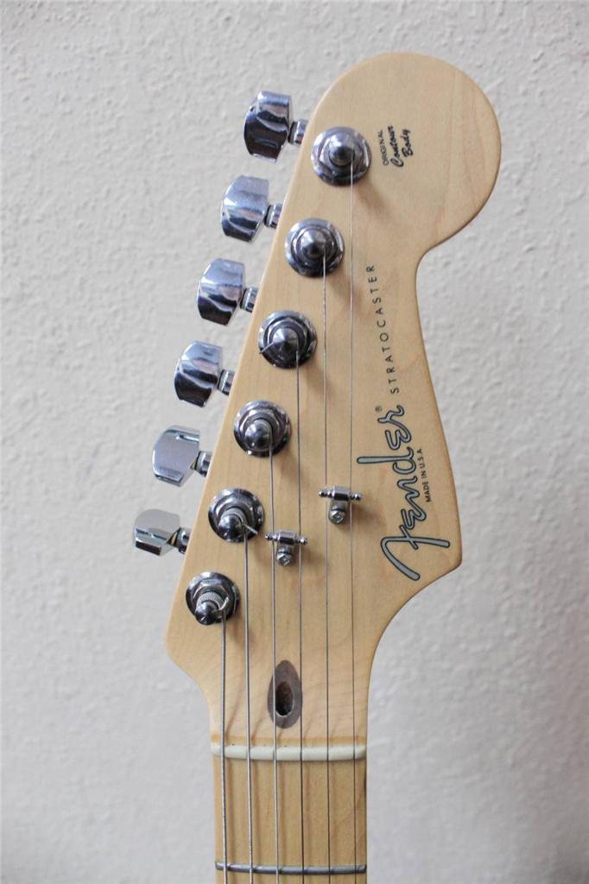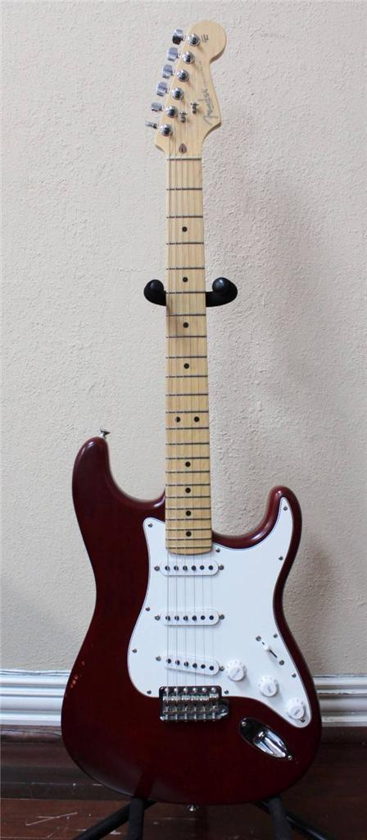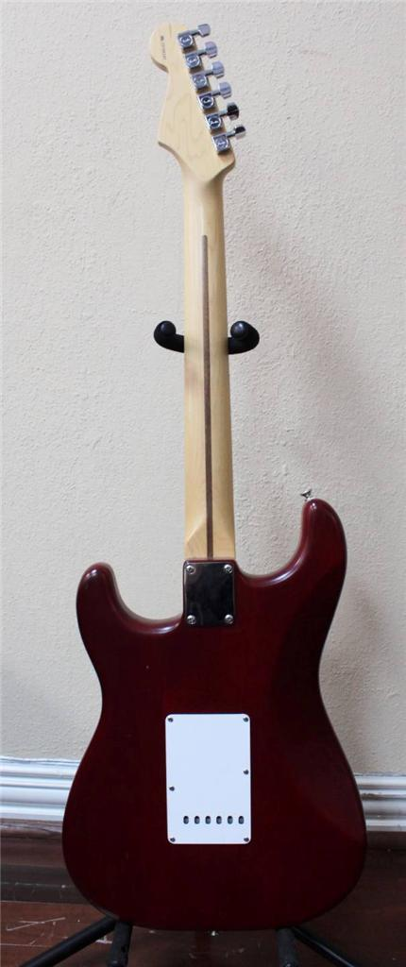

**Strat Highway one version 1**

V2 2006 to 2011

SSS

|  |  |
| --- | --- |
| Headstock | Large 2 string trees |
| Pickguard | White 11 Screw Laminated Plastic White Controls |
| Bridge | 6 point/vibrato unit |
| Finish | Satin |
| Neck | Fretted Maple or Maple with Rosewood |
| Body | Satin Finish Black or Sunburst* |
| PUPs | 3 White 6 polepiece |
| Other features | No micro tilt blank neckplate |

* Again not sure if true throughout but only available in Black and Sunburst as at 2010

HSS

|  |  |
| --- | --- |
| Headstock | Large 2 string trees |
| Pickguard | White 11 Screw Laminated Plastic with black controls |
| Bridge | 6 point/vibrato unit |
| Finish | Satin |
| Neck | Fretted Maple or Maple with Rosewood |
| Body | Satin Finish Black or Sunburst* |
| PUPs | 2 black 6 polepiece 1 black Humbucker |
| Other features | No micro tilt blank neckplate |

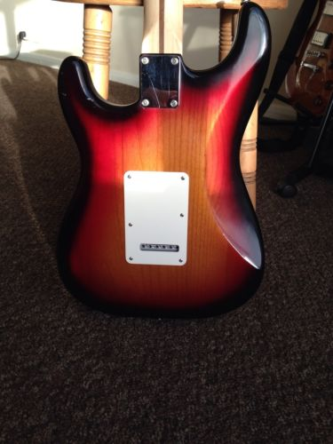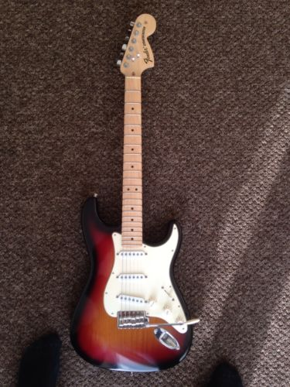

**Strat Highway 1 version 2**

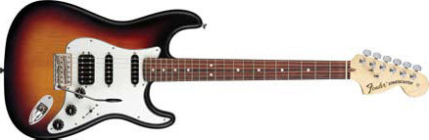

**Strat Highway 1 version 2 HSS**

**American Special** 2010 to date

SSS

|  |  |
| --- | --- |
| Headstock | Large 2 string trees |
| Pickguard | White 11 Screw Laminated Plastic White Controls |
| Bridge | 6 point/vibrato unit |
| Neck | Fretted Maple only |
| Body | Red or Sunburst 2013 surf green added |
| PUPs | 3 White 6 polepiece |
| Other features | No micro tilt blank neckplate |

HSS:

|  |  |
| --- | --- |
| Headstock | Large 2 string trees |
| Pickguard | Black 11 Screw Laminated Plastic with black controls |
| Bridge | 6 point/vibrato unit |
| Neck | Maple with Rosewood |
| Body | Satin Finish Black or Sunburst added Candy Apple red from 2013 |
| PUPs | 2 black 6 polepiece 1 black Humbucker |
| Other features | No micro tilt blank neckplate |

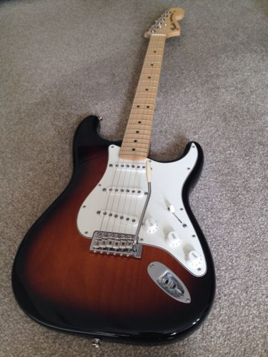 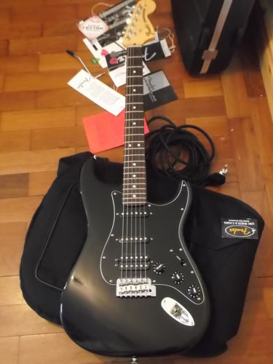

**American Specials**